**PRACTICAL**

**Study of human blood cells through smear technique**

**Aim:**

To identify the blood cell types in human blood smear.

**Materials:**

Methanol (or ethanol)

Buffer solution

Microscope

Glass slides

Spirit lamp

Sterilized needle

A drop of blood

Giemsa stain (Giemsa powder can also be used instead of Giemsa solution)

Distilled water

**Procedure:**

**Preparation of Blood smears:**

1. Obtain 2 clean microscope slides, alcohol wipes, and lancet

2. Clean a finger with an alcohol and puncture with lancet

3. Place a small drop of blood at the end of one slide.

4. Use the second slide to make a thin blood film as directed below:

a. Place the second slide at a 30 degree angle and touch the slide with the blood drop

b. Move the spreader slide to touch the blood drop allowing the drop to spread by capillary action along the edge of the slide

c. Immediately pull/push the slide away from the blood drop, making a thin smear that should dry quickly as you move away from the drop.

d. A perfect smear will have a “feathered” edge and separated RBCs when you view it with the microscope.

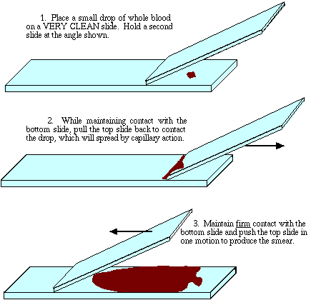

**Preparing staining buffer**

Stock buffers (two)

* The alkaline stock is Sodium phosphate, dibasic anhydrous, N2HPO4 (Sigma Chemical S-0879). Mix 9.5 gm with distilled water to make 1000 mL.
* The acid stock is Potassium phosphate monobasic anhydrous, KH2PO4 (Sigma P5379), mix 9.07 gm with distilled water to make 1000 mL.

Working buffer: Mix 39 mL of acid stock with 61 mL of the alkaline stock, and 900 mL of distilled water. Check pH, and adjust to pH 7 or 7.2 by adding the acid buffer stock to lower pH or alkaline to raise pH. Just a very few mL should be necessary to reach the required pH.

**Prepare staining solution:**

Mix 94 ml buffer solution pH 7,2 with 6 ml Giemsa stock solution >> 5% Giemsa solution.







**Staining the blood smear (Horizontal staining procedure):**

1. Place thoroughly dried smear on horizontal staining rack

2. Flood smear with Fixative (Methanol/Ethanol) for 10 seconds, (fixes cells to slide/prepares cells for dyes) drain

3. Flood smear with Dye* for 10 seconds, drain

4. Rinse the smear with distilled water for 1 minute

5. Air dry and examine under the microscope, using low power first, then high power.

6. Observe as many different types of blood cells as possible. Pay close attention to size, frequency, and nuclear features.

**Observation:**

Different types of blood cells are visible (Neutrophil, Basophil, Eosinophil, Lymphocyte, Erythrocyte, Platelets and Monocytes).

