**STUDY OF KARYOTYPE OF DROSOPHILA**

* **Karyotype** of the individual indicates the number, shape, size of chromosome together with the position of the centromere.
* In present study the salivary gland chromosome would be studied.
* Large sized or giant chromosomes are found in dipterans having a single pair of wings.
* The nuclei of the cells in the salivary glands of larvae of drosophila are two hundreds time larger than the corresponding chromosomes in other somatic cells.
* These chromosomes can easily be stained and observed under the compound microscope after removing them from the salivary glands
* 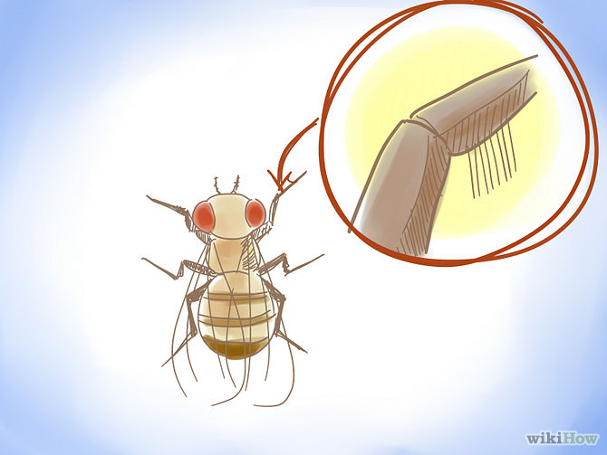

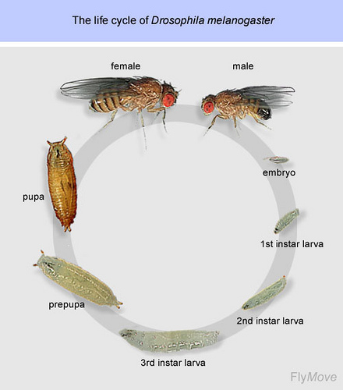

**MATERIALS**

* Drosophila’s larva
* 0.7% saline solution
* Aceto-orcin stain (The Aceto-orcin stain can be prepared by dissolving 1-2g of Orcin in 45ml of hot acetic acid and then dilute with 55 ml of distilled water on cooling).
* Needle/forcep
* Slides
* Cover slip
* Tissue paper
* Microscope
* Nail polish

**DISSECTION OF THE LARVA**

1. The larva to be dissected should be large size, sluggish which had moved out from the medium and are trying to crawl up the container.
2. The larva which show this type of behavior are at 3rd instar.
3. Take the larvae to the dissecting dish and place few drops of 0.7% saline solution on its anterior end of the body.
4. Under the dissecting microscope, with the help of two long dissecting needles/forceps remove the salivary gland.
5. The convenient way of obtaining the salivary gland is to hold the posterior end of the larvae with a dissecting needle/forcep.
6. With the other needle/forcep locate a W-shape area of **black** color under the microscope

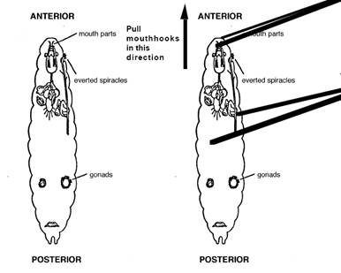

1. Once, it is located, this W-shaped black area is pulled with the help of other dissecting needle/forcep
2. The salivary glands that are enclosed in fat gives a shining appearance along with other mouth parts are also pulled out together with other mouth parts
3. Remove the shiny fat material, the salivary glands are attached anteriorly with one another lifted on the dissecting needle/forcep and transferred on to a slide having few drops of the Aceto-orcin stain

**METHOD FOR STAINING**

* Keep the salivary glands in a small amount of Aceto-orcin for 5-10 minutes after removing the fatty material
* Place a cover slip over the stained material and then wrap a strip of filter paper around it and apply some pressure with thumb. The pressure will spread the cells and the filter paper will absorb the excess stain. If the spreading is not proper then tap the slide cover with a pencil so that the chromosomes should be properly separated
* Seal the edges of the cover slip with the nail polish
* Observe under low and high power of microscope

**RESULTS**

* Chromosomes spread in the field as arms of dark purple colour with dark and light bands
* If properly spread the four pairs of chromosomes would be visible
* The darkly stained region is termed as band where DNA and RNA are present in abundance
* Between two alternate bands, there are present light bands that are made up of proteins and are termed as interband.

